KAUNO TECHNOLOGIJOS UNIVERSITETAS

INFORMATIKOS FAKULTETAS

Programavimo kalbų teorija (P175B124)

Laboratorinių darbų ataskaita

Atliko:

IFF-7/14 gr. studentas

Eigijus Kiudys

2020 m. vasario 24 d.

Priėmė:

lekt. Evaldas Guogis

lekt. Fyleris Tautvydas

KAUNAS 2020

TURINYS

1. Python (L1) 3

1.1. Darbo užduotis 3

1.2. Programos tekstas 4

1.3. Pradiniai duomenys ir rezultatai 6

# Python (L1)

## Darbo užduotis

<https://onlinejudge.org/index.php?option=com_onlinejudge&Itemid=8&category=3&page=show_problem&problem=75>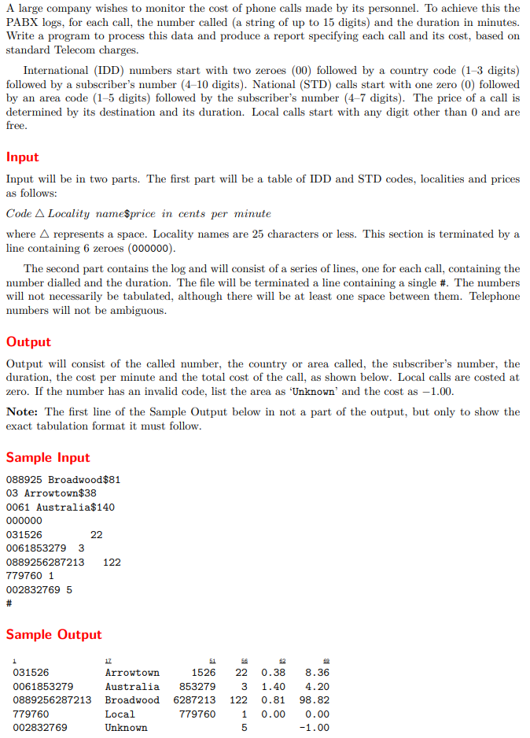

## Programos tekstas

**class** TelephoneInfo:  
 **def** __init__(self, code, name, price):  
 self.code = code  
 self.name = name  
 self.price = price  
  
 **def** priceSeconds(self):  
 **return** round(self.price * 0.1, 2)  
  
**class** TelephoneCalls:  
 **def** __init__(self, number, time):  
 self.number = number  
 self.time = time  
  
**class** Data (TelephoneInfo, TelephoneCalls):  
 **def** __init__(self, number, code, name, price, time):  
 self.number = number  
 self.code = code  
 self.name = name  
 self.price = price  
 self.time = time  
  
 **def** calcuPrice(self):  
 **return** float(self.price) * 0.1 * float(self.time)  
  
 **def** __str__(self):  
 **if** self.code != -1:  
 **return "{0:15} {1:16} {2:8} {3:6} {4:6} {5:.2f}\n"**.format(self.number, self.name, self.code, self.time, str(self.priceSeconds()), self.calcuPrice())  
 **else**:  
 **return "{0:15} {1:16} {2:8} {3:6} {4:6} {5:.2f}\n"**.format(self.number, self.name, **""**, self.time, **""**, float(self.price))  
  
  
**class** Main:  
  
 **def** __init__(self, read, write):  
 self.readFromFile = read  
 self.writeToFile = write  
  
 **def** dataRead(self):  
 data = []  
 file = open(self.readFromFile, **"r"**)  
 **for** dataFromFile **in** file:  
 data.append(dataFromFile)  
 file.close()  
 **return** data  
  
 **def** splitLine(self,dataFromFile):  
 split = []  
 listForInfo = []  
 listForCalls = []  
 info = **False  
 for** i **in** dataFromFile:  
  
 index = 0  
 **if** len(split) == 2 **and** info:  
 split = []  
 **elif not** info:  
 split = []  
  
 **for** string **in** i:  
 **if** string == **" "**:  
 split.append(i[0:index])  
 split.append(i[index + 1: len(i)])  
 **break** index += 1  
 **if** index == len(i):  
 split.append(i.strip())  
split[0] = split[0].strip()  
 **if** len(split) > 1 **and not** bool(info):split[1] = split[1].strip()  
 data = split[1].split(**'$'**)  
 telephoneInfo = TelephoneInfo(split[0], data[0], float(data[1]) * 0.1)  
 listForInfo.append(telephoneInfo)  
 **elif** len(split) == 1 **and** split[0] == **"000000" and not** bool(info):split = []  
 info = **True  
 elif** len(split) > 1 **and** bool(info):  
 split[1] = split[1].strip()  
 calls = TelephoneCalls(split[0], split[1])  
 listForCalls.append(calls)  
 **return** listForInfo, listForCalls  
  
 **def** calculatePrice(self, listOfCall, listOfInfo):  
 calculatedData = []  
 **for** calls **in** listOfCall:  
 state = **False  
 for** info **in** listOfInfo:  
 **if** calls.number[0:len(info.code)] == info.code:  
 data = Data(calls.number, calls.number[len(info.code):len(calls.number)], info.name, info.price,  
 calls.time)  
 calculatedData.append(data)  
 state = **True  
 break  
 elif** calls.number[0] != **"0"**:  
 tempInfo = TelephoneInfo(calls.number, **"Local"**, 0)  
 data = Data(calls.number, tempInfo.code, tempInfo.name, tempInfo.price, calls.time)  
 calculatedData.append(data)  
 state = **True  
 break  
 if not** bool(state):  
 data = Data(calls.number, -1, **"Unknown"**, -1, calls.time)  
 calculatedData.append(data)  
 **return** calculatedData  
  
 **def** saveData(self, calculatedData):  
 fSave = open(self.writeToFile, **"w+"**)**for** data **in** calculatedData:  
 fSave.write(str(data))  
 fSave.close()  
  
 **def** run(self):  
 fileData = self.dataRead()  
 infoList, callsList = self.splitLine(fileData)  
 dataList = self.calculatePrice(callsList, infoList)  
 self.saveData(dataList)  
  
main = Main(**"test.txt"**, **"data.txt"**)  
main.run()

## Pradiniai duomenys ir rezultatai

|  |  |
| --- | --- |
| **Pradiniai duomenys** | **Rezultatai** |
| 088925 Broadwood$81 03 Arrowtown$38 0061 Australia$140 000000 031526 22 0061853279 3 0889256287213 122 779760 1 002832769 5 # | 031526 Arrowtown 1526 22 0.38 8.36 0061853279 Australia 853279 3 1.4 4.20 0889256287213 Broadwood 6287213 122 0.81 98.82 779760 Local 779760 1 0.0 0.00 002832769 Unknown 5 -1.00 |